Title of the Project
[Title: Times New Roman, 12 pt, Bold, Centre, single-spaced, does not exceed 15 words]

Author One, Author Two & Author Three
[Authors: student, supervisor, Times New Roman, 12pt, Centre, Justified, single-spaced]

Affiliation
[Affiliation: Times New Roman, 12pt, Left, Justified, single-spaced, use superscript numbers to indicate different institutions]

Abstract

[Text: Times New Roman, 11 pt, left, justified text]. Abstract must be in one paragraph only and consist of 250-350 words. Abstract must be written in English and free of spelling and grammar mistake. A good abstract will consist of a background, problem statement, objective, novelty, benefits to user and / or society. Do not cite references in the abstract. The abstract should be intelligible to the non-specialist as well as the specialist in your field, and hence should avoid specialized terms and abbreviations. It should be written single-spaced in a single paragraph.
Key words: (italicized) Provide 3-5 key words identifying the nature of the subject matter alphabetically in the last part of the summary.

Introduction
This template provides information for the authors regarding the preparation of their structured book chapter for IIIDentEx 2019. If you are reading a paper version of this document, you can use it to prepare your manuscript to facilitate the review process. Page margins are 2.54 cm top and down, left and right (normal margin).

Highlight a section that you want to designate with a certain style, then select the appropriate name on the style menu. The style will adjust your fonts and line spacing. Do not change the font sizes or line spacing to squeeze more text into a limited number of pages. Use italics for emphasis; do not underline. To insert images in Word, position the cursor at the insertion point and either use Insert | Picture | From File or copy the image to the Windows clipboard and then Edit | Paste Special | Picture (with “Float over text” unchecked).

Content

Figures and Tables
Use times roman for all text and tables. Using this font throughout will reduce problems at typesetting, especially with tables. All figure must be embedded within the text at the appropriate position. Use the Table function of Word to generate tables. Do not insert them as objects. Each table must have a clear and concise title.

All figures and tables should be numbered consecutively (e.g. table 1, figure 1)
Please make sure all figures and tables are not exceeded 50 percent of the pages. Figure, images and tables must be in a good quality. Picture, table or figure must be from original work of the authors. If you retrieve them from other sources, it should be properly acknowledged and must not copyright protected.

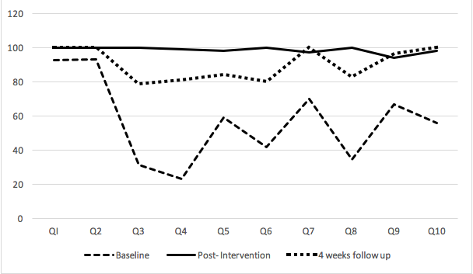
Fig. 1 Percentage of correct answer by respondents

Open-ended questions | Closed-ended questions
What is your main motivator to undertake research activity? | Do you think we have adequate research facilities in this institution?
What you consider as barriers to  undertaking research activities for yourself? | Do you think the incentives from university/ organisation is lacking to motivate you to publish?
What factors that you look at when you choose the journals that you want to submit? | How about the timing of the review process? Does it affect your choice?
Table 1. Example of open and closed-ended questions

Abbreviations and Acronyms
When abbreviating a term, use the full term the first time you use it, followed immediately by the abbreviation in parentheses. : Standard abbreviations like units of measurement and states do not need to be written out.

Language
If your native language is not English, please get a native English-speaking colleague to proofread your paper.

Conclusion
Conclusion for an innovation book chapter may highlights the main point of your innovation and project’s idea. It may also elaborate the importance of such projetcs for the user and society and suggestion for future extension of the project.

References
(APA Style of referencing)

Calfee, R. C., & Valencia, R. R. (1991). APA guide to preparing manuscripts for journal publication. Washington, DC: American Psychological Association.
Doe, J. (2004). An Example of a Chapter in an Edited Volume. A Book on Continuous Innovation. Outback Press, pp. 19-37.
Duncan, G. J., & Brooks-Gunn, J. (Eds.). (1997). Consequences of growing up poor. New York, NY: Russell Sage Foundation.
Schnase, J. L., & Cunnius, E. L. (Eds.). (1995). Proceedings from CSCL '95: The First International Conference on Computer Support for Collaborative Learning. Mahwah, NJ: Erlbaum.
*Please use APA Style. Refer: https://www.apastyle.org/learn/quick-guide-on-references

